

**Direct to Parent How To Guide**

**Parents Guide**

Direct to Parent

**Online Ordering – Getting Started**

Ordering online couldn’t be easier. Simply visit our website [www.swischoolwear.co.uk](http://www.swischoolwear.co.uk) and select either ‘EXISTING PARENT? Login or NEW TO SWI?

# Existing Customer?

If you’re an existing SWI customer, your account and account settings will be available on the new website. The only change will be, for security reasons, we will be asking you to re-enter your password. You will only need to do this once.

Your children will be associated to their existing school.

# New to SWI?

New customers will be asked to register and follow the online instructions to link their account to a chosen school. Once you are registered (and you have added students to a school) you can begin to order straight away. This is the same as the old school.

# School Store

To start shopping with us, once you are logged in, you will need to click on ‘School Store’ in the header of the site. This page will list all of the products associated with your school.

All of the uniform and PE kit products will be displayed with an indication if the product is compulsory. To make things easier, you can easily filter the gender of the products and whether they are compulsory or optional.

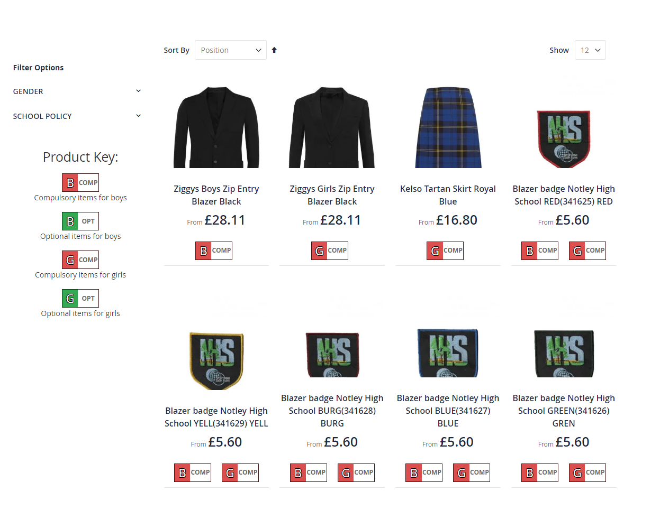

To add an item to your cart, click on the picture or the ‘View Product’ button and you will see a page with more details and size option details. On this page you can then select the size required from the drop down menu and click ***Add to Cart*** button.

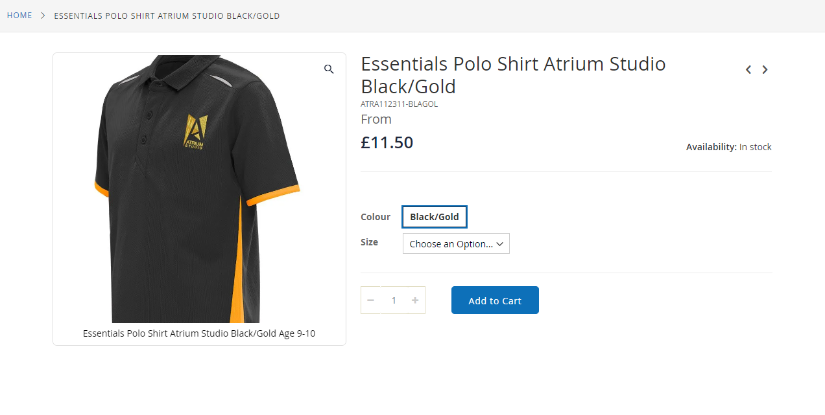

Simply type the quantity you wish to order into the quantity box which will automatically update. Once all items have been added to the cart click ***View Cart*** icon at the top right of your page.

**Shopping Cart**

You will be taken to the cart page to confirm your order. Quantities can be increased / decreased within this screen too.

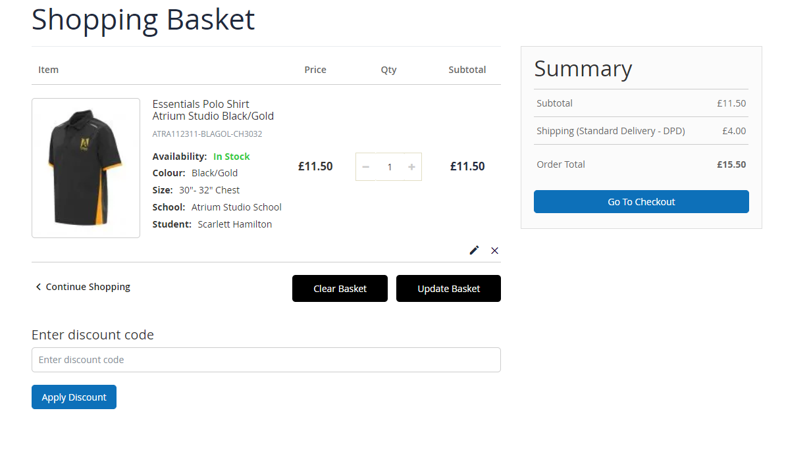

**Checkout – Step 1 of 2**

At Checkout you can select billing and delivery addresses (or select a school delivery if that is an option for you).

**Delivery Notes**

When the parcel is delivered to home these are the notes that you would like us to pass on to the carrier company if you are not home when they come to make the delivery e.g. “Leave within porch” or “Leave with neighbours”. This CANNOT be an alternative delivery address.

An instruction here IS needed. Once delivery notes have been entered click onto the ***Next*** button to enter payment details. If you have nothing, simply put “None”.

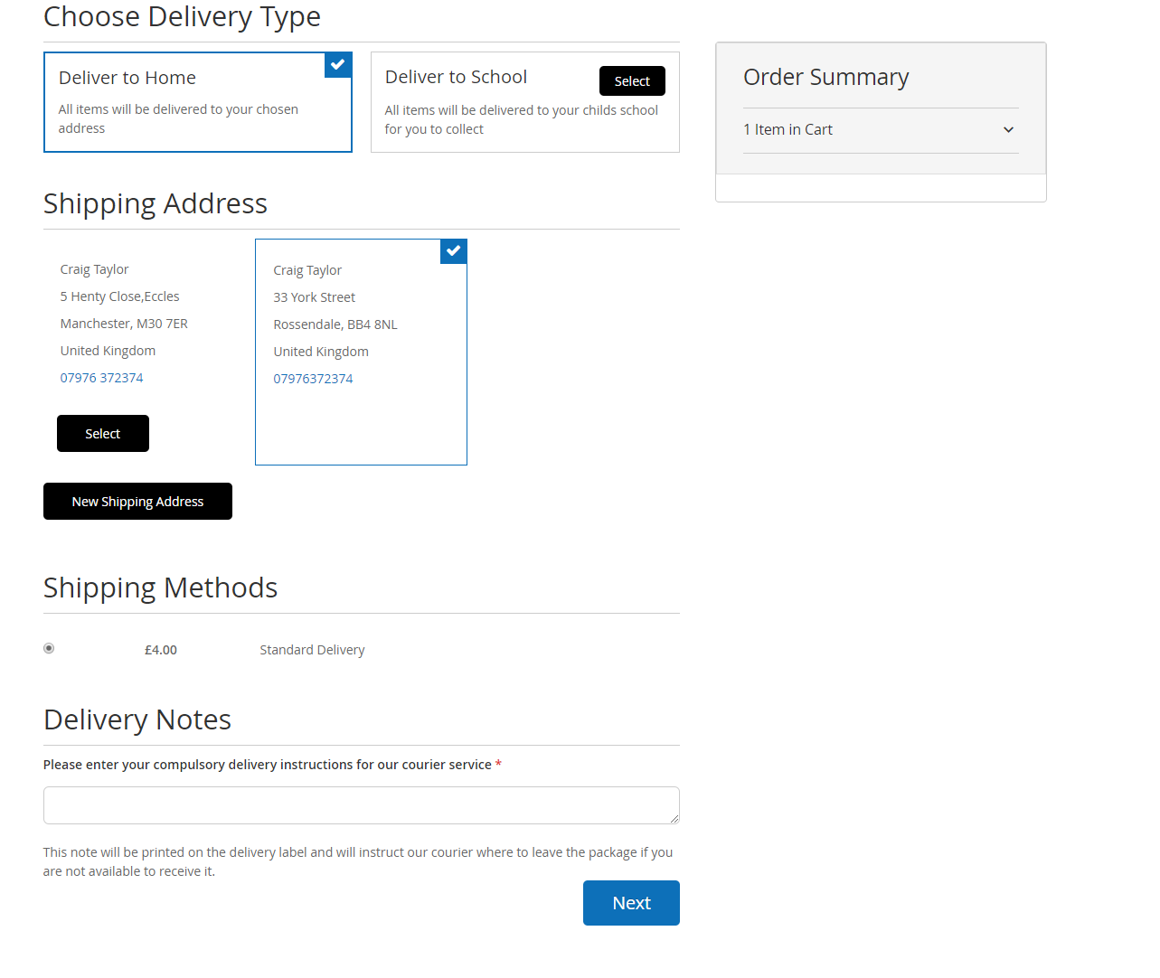

**Payment – Step 2 of**

Payment can be made by Visa, MasterCard, Solo, Maestro. Unfortunately, we do not accept **American Express.**

Click ***Place Order*** button.

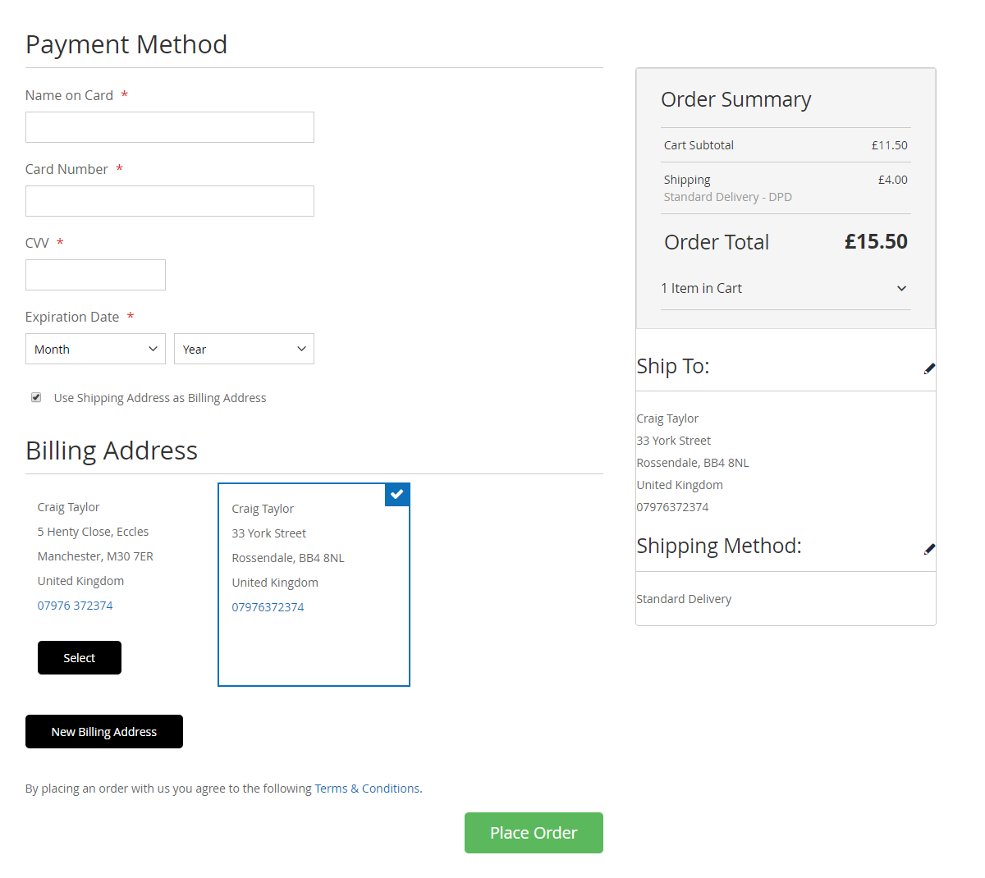

**Order Completed**

Once the order is complete you will receive and order number and email confirmation.

**Phone / Postal Orders**

The school will have paper order forms and a downloadable copy on the school website. If you wish to pay by cheque or do not have access to the Internet then you can phone or post your order using the paper order form.

**Home Delivery Charges**

* Orders over £70 are sent to home free of charge
* Orders under £70 sent to a home address (or other specified) incur a £4.00 delivery charge

**Returns Procedure**

In every dispatch we include a form with full details of how to send items back for a refund using a pre-paid returns label. We offer a 30 day returns policy. Full terms and conditions can be found on our website.

# Web Helpdesk

SWI has a dedicated Web Helpdesk. If you are having difficulty with your online account or logging in then please contact the Team on 01928 752610.

We also have a great FAQs page at <http://www.swischoolwear.co.uk/help> too.