OVERTON GRANGE SCHOOL

Silver Award

An adventure from beginning to end…

Contents

Welcome to the DofE Award
Who’s Who?
Volunteering Section
Physical Section
Skills Section
Expedition Section
Assessors and achieving your Award
Weekly Training
Training Weekend
Equipment required for Expeditions & Training
Expedition Dates & Details

Welcome to the D of E Award
A DofE programme is a real adventure from beginning to end. It doesn’t matter who you are or where you’re from. You just need to be aged between 14 and 24 and realise there’s more to life than sitting on a sofa watching life pass you by.
You can do programmes at three levels, Bronze, Silver or Gold, which lead to a Duke of Edinburgh's Award.
You achieve an Award by completing a personal programme of activities in four sections (five if you're going for Gold).
You'll find yourself helping people or the community, getting fitter, developing skills, going on an expedition and taking part in a residential activity (Gold only).

But here's the best bit - you get to choose what you do!

Your programme can be full of activities and projects that get you buzzing. And along the way you’ll pick up experiences, friends and talents that will stay with you for the rest of your life.

- Write a letter of application. It should be no more than 1000 words, explaining why you want to take part in the Duke of Edinburgh’s Award.
- Complete the application pack
- Make payment of £80* on Parent Pay in one go or via three instalments:
Two instalments of £40 due November 2019 and June 2020
Deadline for Applications: Friday 18th October 2019
*This fee is inclusive of a £21.00 enrolment fee to the DofE charity, annual Licence fee payable to the DofE Charity, Expedition costs and some administrative costs.

Good luck and we hope you join us.
Mrs Hodgson, Mrs Gorley and Mr Gorley
The Programmes___

SILVER

A Silver DofE programme has 4 sections, Volunteering, Physical, Skills and Expedition. You need be at least 15 years old, or turn 15 in your current academic year, to start a Silver programme. You must do a minimum of 6 months activity for the Volunteering section. Out of the Physical and Skills sections, you will choose one to last 6 months and the other for 3 months. You will then plan, train for and do a 3-day (2 night) Expedition.

If you have not achieved your Bronze Award, you will also need to add an additional 6 months onto the longer of the Volunteering, Physical or Skills sections, making one a minimum of 12 months to achieve.

Each activity, you will need to commit at least one hour each week over your chosen timescale.

This table shows what you need to do:

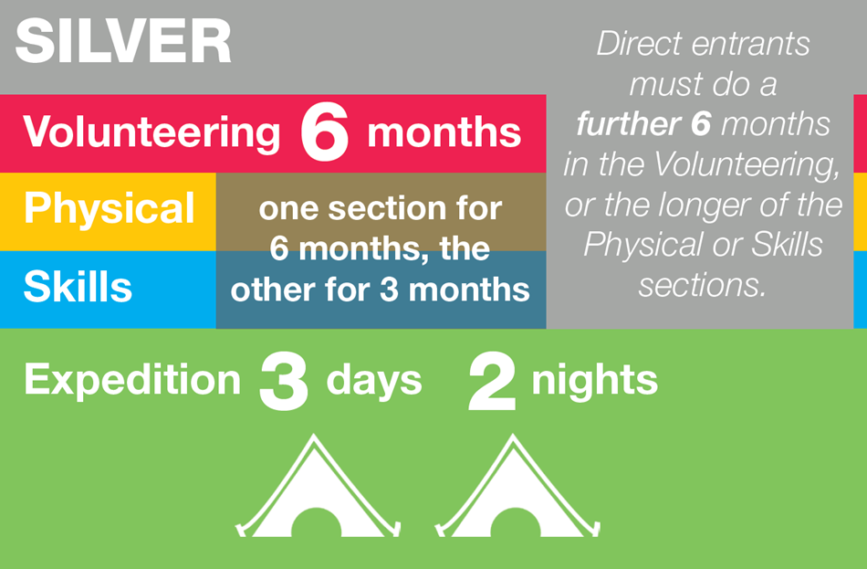

Who’s Who?
The Duke of Edinburgh’s Award at Overton Grange School is run by many staff each with their own skills and interests which enable the students to benefit from our experiences.

The key volunteers who run the programmes are:
Name | Email Address
Mrs Gorley |  | b.gorley@overtongrange.sutton.sch.uk
Mrs Hodgson |  | t.hodgson@overtongrange.sutton.sch.uk
Mr Gorley |  | a.gorley@overtongrange.sutton.sch.uk

For expeditions and training weekends we have a number of other volunteers from the staff to man checkpoints and to offer support to the teams.
We are always on the lookout for more adults to help us out.
Expectations
- Training sessions will take place on a fortnightly basis and participants must endeavour to attend training every week. If for some reason a training session cannot be attended then you must make every effort to inform the staff before the start of the session.
- Absences must only be for illness or unavoidable appointments and will require notes from parents!
- Please think carefully about the programme and only apply if you are determined to fully commit yourself.
- Students who are classified for Pupil Premium can request funding for the Expedition. Please note you must still complete and return the reply slip and that funding is not automatically guaranteed. (The place will be reserved for the student on receipt of the reply slip but if necessary the Finance Office will contact you regarding payment)
- Participants will be expected to start two of their sections as soon as possible, this will be monitored, and two sections need to be completed by the practise expedition and the evidence uploaded on to their eDofE account. We will only take students that have completed sections on our expedition; however, an Approved Activity Provider (AAP) can be found for an additional fee made directly to that company.
- Students will need to buy and wear a polo shirt from the school Tesco online shop on their training walk, practise and actual expedition; this is our expected uniform requirement so that students are clearly identifiable. The sizing’s are generous and cheaper for the participants to order than the supplier used in previous years.
- The cost to enrol onto a programme is £80.00, which can be paid in full or in two instalments of £40.00. The fee is inclusive of:
- £21.00 participation fee from the DofE charity
- Logistical costs associated with the Expedition (campsite fees etc.)
- Administration costs of organising the DofE, including a contribution to the DofE Licence Fee made payable to the charity.
£40.00 of this fee will be non-refundable should your child choose to no-longer take part.

Volunteering
This is all about making a difference to other people's lives. Getting off your sofa and taking time out to change things for the better can be great fun.
You'll need to agree the type of volunteering you want to do, what you plan to achieve and do any training (if you need to) before you get started.
Ben Fogle, TV presenter and Silver Award holder reckons volunteering is a great thing to get involved in:

“Employers and universities recognise the value of having people who have a life away from their job. This is where the DofE comes in, it's now become the leading Award for young people to demonstrate they have interests outside of everyday life. Volunteering gives you a chance to make a difference to others and to their community. I believe that you'll find your voluntary work will increase your confidence and self-esteem and give you new skills. I would advise you all to embrace volunteering opportunities; it's a great way to collect extra experience that could give you the edge at a college, university or job interview.”

In case you're still wondering what you'll get out of the Volunteering section, this is what Sarah has to say about it...
From conservation to youth work to fundraising for your favourite charity or caring for animals, there's an endless list of the types of projects you can get involved in, so have a chat with the staff and other people in your community to find out what’s on offer, what needs doing and who needs help!
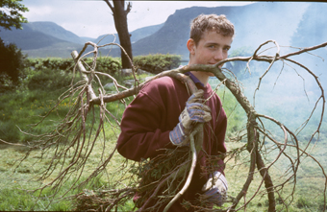
Once you've found an activity or project, you'll need to get someone who's running it to agree to help you through it and sign off your evidence once you've completed to prove you did it - we call them your Assessor. Your Assessor will also check on your progress whilst you're doing the activity.
If you can't find a project you want to do, why not set up a new one that will help your community? This can be on your own, with a couple of friends or even with your whole DofE group – the staff can help you do this and may be able to act as your Assessor.
Remember - you need to get your staff to agree your choice and make sure it fits our rules for the Volunteering section. They'll have a quick meeting with you to make sure you’ve set yourself enough of a challenge, arrange when they'll catch up with you over the time you're volunteering and when you’ll have your final assessment. Then you’re good to go!

Physical
Fancy yourself as the next Wayne Rooney, Kelly Holmes or Tony Hawk? Well now’s your chance to prove it! This part of your DofE programme is all about getting active. Whether you’re into sports, dance or general fitness it doesn’t matter – you can choose to do something you’re interested in.
You don’t need to be star athlete or the fittest person in the world to complete your Physical section. As long as you have fun, get better and fitter, then you’ll have done it!
“Playing for the local football team really helped me get fit – and I watch what I eat now (less crisps!) so I have the energy to keep going for 90 minutes! I’ve enjoyed learning about game strategies too and it’s my challenge to make sure I get picked for the first team every week.”

George, DofE participant

From playing for a local sports club to weekly dance classes, from free running to yoga, from ultimate flying disc to wheelchair football, almost any dance, sport or fitness activity can count. Have a chat with the staff, your friends and family to see what’s around locally.
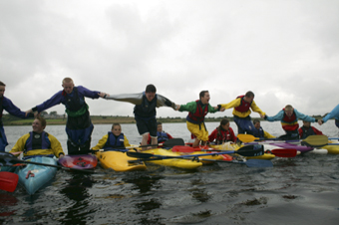
Once you’ve decided what you want to do, you need to find an adult who needs to know what you’re aiming to achieve, can help you through your section and sign your Record Book at the end of it to prove you did it. This is your Assessor and, for your Physical section, this is likely to be the person who’s running the activity you do, for example your sports coach, dance teacher or gym instructor.

If you choose to do an activity on your own, why not ask the staff to be your Assessor?
With the help of your Assessor, agree a time frame and set yourself some goals to aim for – just make sure they’re going to challenge you. You could choose to aim for a standard or award set by the sport or activity’s governing body.

Then check your choice and goals with the staff, get their approval and agree when to catch up with them whilst you’re doing your activity. As soon as this is done, it’s time to get active!

Skills
Ever wanted to have a go at something completely different? Or get recognised for the time and effort you put into your favourite hobby? This is what the Skills section is all about.
From podcasting to painting, from DJing to driving, from music to making kites, whatever skill you choose can allow you to develop new talents or perfect existing ones. Follow a passion or discover a new one, the choice is yours.
Once you’ve chosen your skill you’ll need to decide how long you’re going to do it for and set yourself some objectives – what you want to get out of doing it. You’ll then need to find someone who will agree to be your Assessor – they need to have some knowledge of the skill you’re doing so they can help you along the way and agree at the end that you’ve met your goals.
“I learned so much…the tutors were such talented musicians. The highlight was taking part in the ‘Proms in the Park’ celebrations which was televised live.” Laura, Silver Award holder

As soon as you have all this in place just check with the staff before you start – this enables us to establish whether you’ve ‘ticked’ all the boxes needed to progress towards achieving your Award and that you’ve set yourself enough of a challenge. They’ll also make sure what you’ve chosen counts for the Skills section, for example, dance is physical, but dance appreciation is a skill.

Expedition
Achieving your Award is an adventure from beginning to end and this section can give you some of your most memorable experiences!
From sailing along the Norfolk Broads to walking in Canada or horse riding in the Brecon Beacons, it can as far-flung or as close to home as you want it to be. You can also choose how you want to travel – it doesn’t just have to be on foot! You could choose to do your expedition by bike, by canoe, by kayak, by wheelchair, by sailing boat or even on a horse or llama!
There’ll need to be between four and seven of you in an expedition team and once set does not change. With your team, you’ll plan an aim for your expedition, decide on your location and do lots of fun training to make sure you’re fully prepared and know what you’re doing!
“…We depended solely on everyone working as one. We had very low points, but when we had highs, they were exceptionally high…I still keep in touch with my team… this has to be one of the best things I have done…” Tim, Silver Award holder
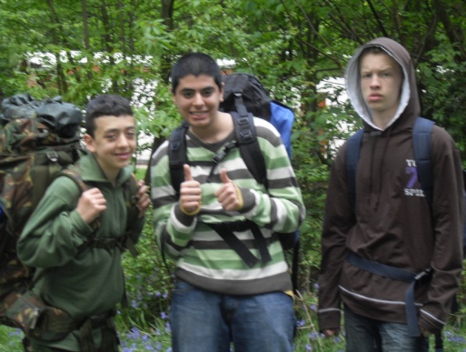

The staff will arrange a Supervisor to work with your team to organise all of this and help you plan your expedition. Once you’ve done the preparation the fun starts when you go out and do a practice and a qualifying expedition. Once you’ve completed your final expedition you’ll give a presentation about your experiences and your achievements to your Supervisor, Assessor or another adult.

The whole experience will give you laughs, arguments, joy and frustration along the way. But, by the end, you’ll have better team and leadership skills, not to mention bags more confidence and a rucksack full of great memories!

Assessors and achieving the Award_______________
Assessors
Participants will need to identify an independent assessor for their Volunteering, Physical and Skills section; the Assessor for the Expedition section will be provided by the school.
The Assessor must be a person over the age of 18, have more knowledge of the activity than the young person, be available over their chosen timescale and be happy to provide their contact details.
The Assessor is normally the person who is running the activity you are attending. Examples of Assessors include: Charity shop manager, football coach, youth worker, teacher running the afterschool activity etc. However, Assessors MUST be independent. Therefore, they CANNOT be a member of your family.
Your Assessor’s will need to write one report at the end of your timescale to confirm:
- The dates you started and finished the activity
- How often you attended
- How you improved in the activity and if you achieved your goal
- Be signed and dated
- Include at least one contact detail.
Please ensure you ask your Assessor for permission at the start of the timescale. Do not wait until the end to tell them it is for your DofE programme.

eDofE and achieving your Award
You will record and evidence your programme online using a system called “eDofE”. On this system, participants will advise staff of their activity choices, by completing their “programme planners” which will be submitted to their Leader for approval.
They must upload their Assessor Report once they have met the minimum timescale and also submit this for approval.
Once the programme planner and Assessor report have been approved by staff, your Award can be submitted for the final approval. It is only once this has been done that you have achieved your full Award.
Additional evidence can be added to further show your commitment and achievements and can help show you have met the requirements. This can include a diary log of attendance, receipts of activities, photos, certificates, PowerPoint presentations etc. but these are not mandatory.

Training
Over the course of the year you will be working towards skills to help with your expedition.
Training sessions will take place on a fortnightly basis and you will be informed via SMHW of any changes in room or session plan.
These sessions will begin at 3.30pm and last until 4.30pm (or 5.00pm on some occasions).
We will have two sessions before Christmas and the bulk of the training will start after February half term.

These skills will include:
- First Aid
- Emergency Procedures
- Health and Safety
- Navigation
- Route Planning
- Map Skills
- Compass Skills
- Equipment and Hygiene
- Country and Highway Code
- Observation and Recording Skills

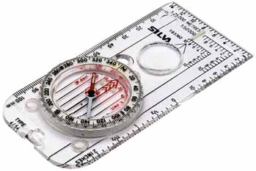
Expedition Requirements
There are two types of expedition; the practice and the assessed.

Here are some key guidelines for both expeditions:

- Under DofE requirements, participants must complete training, at least one practice, successfully complete the qualifying venture and complete a presentation to achieve this section.
- It is a minimum of one practice expedition; should staff feel participants are not ready to move onto the qualifying venture, they may be asked to complete another practice.
- There will be specific check points which will be manned by staff along the way but staff will not be accompanying groups between these points.

- Each participant will have an expedition booklet which has emergency contact details in if needed and they must have this to hand throughout the expeditions.

- We will provide extra drinking water for them to refill bottles along their route. It is vital that all participants drink plenty of water to keep themselves hydrated throughout the walk.

- Changeable weather is very likely so participants must ensure they are prepared with waterproof clothing, a hat and sun cream.

- There is a full kit list in this booklet and on the school website.

- Under DofE rules, mobile phones are not permitted on the expeditions, however, we will provide each group with a phone that can be used in case of an emergency.

- We will collect personal mobile phones at the start of each expedition therefore ideally these should be left at home.

Notes for assessed expeditions:

- There are 20 conditions participants must meet to successfully complete the qualifying venture. Participants will be trained to meet these conditions, which are checked by a DofE Accredited Assessor.
- Participants must be aware that they will have an assessor attached to their group so must take note of the information given to them about the use of mobile phones and other electrical devices, not sticking to their route card and walking on roads.

If young people are seen to be doing any of the above or do not meet all 20 conditions, they will run the risk of not completing the venture and will need to repeat the trip.
Equipment for Expeditions & Training
Personal Equipment | ‘Camping’ Equipment Details
1 pair walking boots (broken in) | Bowl
2 pairs walking socks | Cutlery Set
2 pairs sock liners (optional) | Mug
2-3 t-shirts | Personal 1st Aid Kit
2 fleece tops or similar | Plate
2 walking trousers (warm, NOT jeans) | Rucksack liner
Nightwear  Underwear | Rucksacks
1 pair of trainers (optional) | Sleeping Bags
1 warm hat | Sleeping mat
1 sunhat (if appropriate) | Survival bag
1 pair gloves (if appropriate) | Tents
1 pair shorts (if appropriate) | Torch
Sun cream (if appropriate) | Whistle
1 pair gaiters (optional) | Spare batteries & bulb for torch
1 waterproof jacket AND over-trousers | 1 water bottle (1-2 Litres)
1 watch | 1 box of matches (in container)
1 wash kit | Spare Batteries
1 towel | Food for expedition
1 Tea Towel
1 Bronze DofE t shirt from the online Tesco shop
Group Equipment Provided by School | Other Optional Items
Camping stove(s) | Camera
Cooking pans | 1 notebook & pen/pencil
Maps (1:50 000/1:25 000)
Compass(es)
Fuel for the stove
There are many specialist pieces of equipment that are necessary for safe expeditions. These are listed below along with general equipment required to be provided. These specialist items can be purchased in the high street or through the school at lower prices. The school has a limited number of different sized tents and rucksacks that can be borrowed if requested. This will result in a £10 refundable deposit if the equipment is returned as leant
Silver Expedition Dates & Details
Silver Practice Expedition _________________

This will take place on 24th- 26th April

Participants will need to be dropped off 20 minutes before their allotted start time at a pre-set location. All groups should be finished by 3.30pm on Sunday afternoon and will need to be collect from the same address as the drop off point.

The route followed is circular to the campsite on the Saturday and back from the campsite on the Sunday to the pre-set location.

There will be specific check points which will be manned by staff along the way but staff will not be accompanying groups.

What is required:

- Expedition Equipment
- Rucksack containing personal equipment
- Packed Lunch for Saturday
- Food for main meal on Saturday, Sunday Breakfast and Lunch
- Small amount of emergency money

Dates: | Friday 24th April – Sunday 26th April 2020
Start Time: | From 8.30am
Finish Time: | From 3.30pm

Silver Expedition Dates & Details continued
Silver Assessed Expedition _____

This will take place on 10th – 12th July 2020

Participants will need to be dropped off 20 minutes before their allotted start time.

All groups should be finished by 3.30pm on Sunday afternoon and will need to be collect from the same address as the drop off point.

The route followed is circular to the campsite on the Saturday and back from the campsite on the Sunday to the pre-set location.

There will be specific check points which will be manned by staff along the way but staff will not be accompanying groups.

What is required:

- Expedition Equipment
- Rucksack containing personal equipment
- Packed Lunch for Saturday
- Food for main meal on Saturday, Sunday Breakfast and Lunch
- Small amount of emergency money

.
Dates: | Friday 10th July – Sunday 12th July 2020
Start Time: | From 8.30am
Finish Time: | From 3.30pm

As per previous years, depending on numbers we may have to provide more than one weekend for the practise and expedition. We will send a letter out via email if this becomes the case and allow groups to pick their preferred weekend.

