**A-Levels**

**and**

**BTEC courses**



**INTRODUCTION**

We have a wide range of Advanced (A) Level courses available at Overton Grange.

The A-level courses are two year linear courses with all examinations taken at the end.

Most students who take this pathway will study three A-Levels however where students have done very well in their GCSEs they are welcome to study four subjects at A-Level. The school will advise students as to whether this option is suitable for them or not during the induction process.

In addition to A-level courses we offer the BTEC Level 3 Diploma in Business which is the equivalent of two A-levels each. We also offer the BTEC Level 3 Extended certificates in Business, ICT, Travel & Tourism and Health & Social Care which are the equivalent of one A-level each. These courses, which must be followed for two years to receive a qualification, are good for students who prefer doing coursework to exams. They can be combined with other A-level courses and are accepted for entry into Higher Education.

Finally, we will also provide students with the opportunity to retake GCSE Maths and GCSE English Language if required.

Mr. S. O’Neill

Assistant Headteacher

Post-16 Learning

**Choosing a course**

We offer a diverse range of A-Level and BTEC courses at Overton Grange Sixth Form. When choosing which courses to study, it is important to consider the following:

**Which subjects do you enjoy learning?**

It is vital that you enjoy the subjects you choose. The demands and rigour of A-Level and BTEC study are great and students must be motivated and ready to excel from the start of the course.

**Which subjects are your strengths?**

You must choose subjects where you have a proven track record of success. This will ensure that you achieve highly at A-Level and BTEC. If you are considering a new subject, then you should have success in a related or similar subject at GCSE.

**Which subjects are required for the career or degree you wish to follow?**

It is important to research the requirements for different careers and degree courses before making your decision. Use the UCAS Course Search facility to identify which university courses require A-levels. Talk to your teachers in school to gain advice about different career pathways. You may wish to read the Russell Group “Informed Choices” booklet which is available online and gives details of the subjects preferred by the top universities.

**What are your predicted GCSE grades?**

All our courses have entry criteria which must be met in order to be enrolled. Please check that you are likely to meet the GCSE entry criteria for the courses you wish to follow.

**What is your learning style?**

Although having the necessary grades are important you should also consider what type of learner you are as this may influence your choice of course too. For example, do you like theory-based exams, reading, writing long essays, doing practicals, physical work, coursework, being creative and expressive or problem solving? Different subjects have different skill-sets and may be taught and assessed in different ways. You should aim to try and choose subjects that match your particular way of learning.

Further advice and guidance will be available at our Sixth Form Open Evening from Heads of Department and members of the Sixth Form Management Team.

**Subjects offered**

Below is a list of all the subjects we **currently** offer and you will find individual required grades on the subject information page in this booklet. Please look at this carefully to ensure you are choosing subjects suited to you.

Please note that the school **reserves the right not to run a course** if there is an insufficient number of applications.

**A-level subjects**

Art

Biology

Business Studies

Chemistry

Economics A

English Language

English Literature

Film Studies

French

Further Mathematics

Geography

German

Government & Politics

History

Law

Mathematics

Media

PE

Philosophy and Ethics (Religious Studies)

Physics

Psychology

Sociology

Spanish

**BTEC Level 3 subjects**

Business Studies (Extended Certificate=1 choice, Diploma=2 choices)

Health and Social Care (Extended Certificate=1 choice)

Information Technology (Extended Certificate=1 choice)

Travel & Tourism (Extended Certificate =1 choice)

**EPQ (Extended Project Qualification)**

We recruit for this course during Year 12. Please do not choose it as one of your A Level/ BTEC options.

**INDEX**

**A-Levels & BTEC Level 3 courses Page**

EPQ 6

Art and Design (Fine Art) A level 7

Biology A level 8 Business Studies A level 9

Business BTEC Level 3 National Extended Certificate (= 1 A level) 11  
 Business BTEC Level 3 National Diploma (= 2 A levels) 12  
 Chemistry A level 13

Economics ‘A’ A level 14

English Language A Level 15

English Literature A level 17

Film Studies A Level 19

Geography A level 20

Government and Politics A level 21

Health & Social Care BTEC Level 3 Extended Certificate (=1 A level) 22

History A level 23

Information Technology BTEC Level 3 25

Law A Level 26 Mathematics and Further Mathematics A level 27 Media Studies A level 29

Modern Foreign Languages: French, German, Spanish A level 31 Philosophy & Ethics (Religious Studies) A level 32

Physical Education A level 34

Physics A level 36

Psychology A level 37 Sociology A level 38

Travel and Tourism BTEC Level 3 Extended Certificate (=1 A level) 39

**EPQ**

The Extended Project Qualification (EPQ) is a standalone qualification designed to extend and develop students. The EPQ is awarded UCAS points worth half an A-level and is recognised by universities and employers.

The EPQ requires students to carry out research on a topic that they have chosen and is not covered by their other qualifications. They then use this research to produce a written report and, in the case of practical projects, an artefact or a production. Students begin the process at the end of Y12 and will have completed it by the February half term of Y13.

A student can take inspiration from something studied in class or something completely unrelated to their studies. Some students have explored something personal to themselves for example creating a gluten free cook book through to designing and making a computer game. Alongside this there have been formal essays including topics as diverse as the Iranian revolution to Philosophy and ethics.

The EPQ is overseen by a project supervisor, typically a teacher who is **not** a specialist in the chosen area. The supervisor guides their student through the process; they do not guide the content or unduly influence the outcome of their research, so it is often preferable that a supervisor isn't a subject expert. The final product is internally marked and externally moderated.

The EPQ allows students to embark on largely self-directed projects. By taking responsibility for the choice and design of an individual project (or an individual role in a group project) students:

* become more critical, reflective and independent learners
* develop and apply decision-making and problem-solving skills
* increase their planning, research, analysis, synthesis, evaluation and presentation skills
* learn to apply new technologies confidently
* demonstrate creativity, initiative and enterprise.

**Exam Board: Edexcel**

**Staff contact: Mrs Floyd-Williams**

**Art and Design (Fine Art) A Level**

**What do I need to know, or be able to do, before taking this course?**

Before undertaking A-level Art and Design, you should ideally have achieved at least grade 6 at GCSE, or equivalent. It is expected that you have experience of using art materials and processes together with some knowledge of contemporary and historical art and design. More importantly, you should have a commitment to and love of the subject and feel motivated to develop your visual skills and express your ideas.

The department would like to see a portfolio of GCSE work for all students before starting the course.



**What will I learn?**

The A-Level courses cover a range of techniques and approaches. The A-Level includes the more in-depth Personal Study element. You will have the opportunity to experiment with different media in order to explore your strengths and preferences. The main aim of both courses is to develop your visual language skills in Fine Art. This is work produced as an outcome of personal experience rather than work which is created mainly for a practical function or which is the outcome of a tightly prescribed brief. Work will demonstrate the use of formal elements and creative skills, giving visual form to individual thoughts, feelings, observations and ideas. Disciplines will include painting, drawing, printmaking, sculpture and digital photography

**A level**

Component 1: Personal Investigation in the first year plus, in the second year, the Personal Study, 3000 words, 60% internally marked.

Component 2: Externally set assignment, 40% internally marked.

**Is this the right subject for me?**

This course is suitable for students who are:

* keen to develop their visual skills
* creative, enthusiastic and imaginative
* able to sustain an investigation
* enjoy galleries and discussing art work
* willing to experiment and take risks in their work
* wish to continue with the subject in some form at higher level or as a career

**The future?**

On completion you might progress to further or higher education. Courses might include BTEC Foundation / National / Higher National Diplomas in Art and Design or a degree course of your choice at university. Admission to these and any art-based courses is, in the first instance, by submission of a portfolio of work. This A-level course gives you the opportunity to put together a portfolio. It is essential to take this course if you are considering future entry to art college. Each year students secure places to study art at universities including Kingston University, University of the Arts London and University for the Creative Arts.

**Exam Board: Edexcel**

**Staff contact: Ms Winbourne**

**Biology A Level**

**What qualifications do I need to begin the course?**

Students are required to have a minimum of Grades 5/6 in Combined (Trilogy) Science. Triple science students require a minimum Grade 6 in Biology and a Grade 5 and 6 in the other two sciences.

A grade 5 in Maths is also highly recommended but not essential.

We are sorry, but students who have taken BTEC Applied Science will not be accepted on to A level Biology.

**What does the course involve?**

This course consists of six modules taught over two years:

**Year 12**

Module 1: Development of practical skills in biology (delivered via other modules)

Module 2: Foundations in biology

Module 3: Exchange and transport

Module4: Biodiversity, evolution and disease

**Year 13**

Module 1: Development of practical skills in biology (delivered via other modules)

Module 5: Communication, homeostasis and energy

Module 6: Genetics, evolution and ecosystems

[](http://www.google.co.uk/url?sa=i&rct=j&q=dna+double+helix&source=images&cd=&cad=rja&docid=cs8oMHugGA84UM&tbnid=0oQLfb2gBQZgXM:&ved=0CAUQjRw&url=http://www.billfrymire.com/blog/dna-double-helix-image-of-the-week/&ei=8d1XUqb3LofJhAe2jYHgDA&bvm=bv.53899372,d.ZGU&psig=AFQjCNHbOk4BWTZV6EFnHteOCH6tLiThsg&ust=1381576456375710)

**How is the course assessed?**

The course is assessed by three written exams at the end of Year 13. The three exams are:

* Biological processes (Modules 1, 2, 3 and 5) – 100 marks, 2 hour 15 minute written exam
* Biological diversity (Modules 1, 2, 4 and 6) – 100 marks, 2 hour 15 minute written exam
* Unified Biology (Modules 1 to 6) – 70 marks, 1 hour 30 minutes written exam

There is also a separate qualification of *Practical endorsement in biology*, assessed internally through practical work and reported separately to the A level grade.

**The Future?**

Success on this course could see you move on to study for a degree course in related subjects such as marine biology, biochemistry, biology, pharmaceutical science or nursing. Students have gone on to a range of Higher Education courses including Liverpool (Medicine), St George’s (Medicine), King’s College London (Biochemistry), Nottingham (Zoology, Medicinal and Biological Chemistry), Exeter (Radiography), Leicester (Biochemistry), Brighton (Physiotherapy), Dundee (Anotomical sciences) and Portsmouth (Biology; Marine Biology). Related careers include physiotherapy, forensic science, teaching or agriculture.

**Exam Board: OCR**

**Staff Contact: Miss Nadeem**

**Business Studies A level**

**What qualifications do I need to begin the course?**

All students meeting the Sixth Form entry criteria (5 GCSEs at 9-4) will be considered. It is useful but not essential to have studied Business before.

**What does the course involve?**

**Unit 1: Marketing and people**

* meeting customer needs
* the market
* marketing mix and strategy
* managing people
* Entrepreneurs and leaders.

**Unit 2: Managing the business**

**environment**

* raising finance
* financial planning
* managing finance
* resource management
* External influences.

**Unit 3: Business decisions and**

**Strategy**

* business objectives and strategy
* business growth
* decision-making techniques
* influences on business decisions
* assessing competitiveness
* Managing change.

**Unit 4: Global business**

* globalisation
* global markets and business

expansion

* global marketing
* global industries and companies (multinational corporations)

**How is the course assessed?**

**Paper 1 Marketing, people and global businesses - 9BS01**

35% of final grade

Overview of content

Paper 1 will assess marketing, people and global businesses. Questions will be drawn from Themes 1 and 4, and from local, national and global contexts.

● Written examination.

● Sections A and B each comprise one data response question broken down into a number of parts, including one extended open-response question.

● Duration: 2 hours.

● 100 marks available.

**Paper 2 Business activities, decisions and strategy –9BS0/02**

35% of final grade

Paper 2 will assess business finance and operations, business decisions and

strategy. Questions will be drawn from Themes 2 and 3, and from local, national

and global contexts.

**Overview of assessment**

● Written examination.

● Sections A and B each comprise one data response question broken down into a number of parts, including one extended open-response question.

● Duration: 2 hours.

● 100 marks available.

**Paper 3: Investigating business in a competitive environment -9BS0/03**

● Externally assessed

30% of the total qualification

Overview of content

Paper 3 will assess content across all four themes. Questions will be drawn from

local, national and global contexts.

For Paper 3, there will be a pre-released context document. The context will focus on a broad context, such as an industry or market in which

businesses operate.

* Students are required to apply their knowledge and understanding from Themes 1, 2, 3 and 4 and their understanding of the broad context to this evidence.

Overview of assessment

● Written examination.

● the paper comprises two sections.

● Sections A and B each comprise one data response question broken down into a number of parts, including one extended open-response question.

● Duration: 2 hours.

● 100 marks available.

There is NO coursework involved in this A level.

**The skills you will gain are:**

* Data skills - you will be expected to manipulate data in a variety of forms and to interpret their results
* Present arguments and making judgments and justified recommendations on the basis of the available evidence
* Recognise the nature of problems, solving problems and making decisions using appropriate business tools and methods
* Plan work, taking into account the demands of the task and the time available to complete it
* Challenge your own assumptions using evidence that has become available.

**The Future?**

* A knowledge of business is useful in all careers, including advertising, banking, accountancy, logistics, management, marketing, personnel, public relations, retail and sales. You could go on to run your own company or work for any organisation.
* Many students continue onto related Higher Education courses. Students have secured places on courses including marketing, international business management, accounting and finance, economics, business enterprise development, business and politics, hospitality management and management science. In recent years students have gone on to study related courses at the universities of Sussex, Southampton, Loughborough, Aston, Brighton, Kingston, Bournemouth, Portsmouth and Sheffield Hallam.



**Exam Board: Edexcel**

**Staff Contact: Mrs. Hodgson**

**Business**

**BTEC Level 3 National Extended Certificate**

**What is a BTEC Level 3 National Extended Certificate in Business?**

A BTEC Level 3 National Extended Certificate is a Level 3 course (equivalent to 1 A level) that is studied for two years (Years 12 and 13). It provides a specialist work-related qualification. You will gain the knowledge, understanding and skills necessary to prepare you for employment. It offers flexibility and a choice of emphasis through the specialist units.

**What qualifications do I need to begin the course?**

5 GCSEs 9-4, BTEC qualifications are accepted and students should aim to get a merit grade. However, it is not necessary for Business to have been studied before.

**What will you study?**

1 Exploring Business

2 Developing Marketing Campaign (externally assessed)

3 Personal and Business Finance (externally assessed)

*Plus, one specialist area from:*

* Recruitment and Selection Process
* Investigating Customer Services
* Market Research
* The English Legal System
* Work experience in Business

**How is the course assessed?**

This course is assessed both through coursework and external assessments. One external assessment will be evaluating a marketing campaign you develop in a controlled environment. The other external assessment will be a personal and business finance exam. Your course work is continually assessed throughout the year. There are strict deadlines for coursework to be handed in.

**The Future?**

You could become an entrepreneur,

progress into or within employment, or

continue your study in the vocational area at a further education establishment or go onto university. Recent BTEC students have gone on to universities including Brighton, Kingston, Bournemouth and Roehampton.

**Additional information:**

The majority of this course is completed through using computers and presentations. The course will focus a lot on group work, role plays and an optional work experience placement.

Outside speakers come into to offer their advice and knowledge.

Business trips to e.g. to Thorpe Park are organised by the Business Studies department to assist with your coursework.

**Exam Board: Edexcel**

**Staff Contact: Mrs. Hodgson**

**Business**

**BTEC Level 3 National Diploma**

**What is a BTEC Level 3 National Diploma?**

A BTEC Level 3 National Diploma is a Level 3 course (equivalent to 2 A’ levels) that is studied for two years (Years 12 and 13). It provides a specialist work-related qualification. You will gain the knowledge, understanding and skills necessary to prepare you for employment. It offers flexibility and a choice of emphasis through the specialist units.

**What qualifications do I need to begin the course?**

5 GCSEs 9-4, BTEC qualifications are accepted and students should aim to get a merit grade. However, it is not necessary for Business to have been studied before.

**What will you study?**

1 Exploring Business

2 Developing Marketing Campaign (externally assessed)

3 Personal and Business Finance (externally assessed)

4 Managing an event

5 International Business

6 Principles of Management (externally assessed)

*Plus two specialist areas:*

* Recruitment and Selection Process
* Creative Promotion

These units will be based on international, national and local businesses.

**How is the course assessed?**

This course is assessed both through coursework and external assessments.

One external assessment will be evaluating a marketing campaign you develop in a controlled environment. The other external assessments will be a personal and business finance exam and an assessment on principles of management. Your course work is continually assessed throughout the year. There are strict deadlines for coursework to be handed in.

**The Future?**

You could become an entrepreneur,

progress into or within employment,

continue your study in the vocational area at a further education establishment or go on to university. Recent BTEC students have gone on to universities including Brighton, Kingston, Bournemouth and Roehampton.

**Additional information:**

The majority of this course is completed through using computers and presentations. This year the course will focus a lot more on group work, role plays and a work experience placement.

Outside speakers come in to offer their advice and knowledge.

Business trips e.g. to Thorpe Park are organised by the Business Studies department to assist with your coursework.

**Exam Board: Edexcel**

**Staff Contact: Mrs. Hodgson**

**PLEASE NOTE: THIS OPTION IS EQUIVALENT TO TWO A-LEVELS AND TAKES UP TWO OPTION BLOCKS. YOU MUST SELECT BOTH.**

**Chemistry A Level**

**What qualifications do I need to begin the course?**

For GCSE Triple Science students, a grade 6 in Chemistry and a grade 6 in Mathematics are minimum requirements, with at least a grade 5 in both Biology and Physics.

For GCSE Combined Science students, grades 6 and 5 in Science and a grade 5 in Mathematics are the minimum requirement. We are sorry, but students who have taken BTEC Applied Science OR Trilogy GCSE Foundation Tier will not be accepted on to A-level Chemistry.

**What does the course involve?**

This course consists of six modules taught over two years:

**Year 12**

Module 1: Development of Practical Skills in Chemistry

Module 2: Foundations in chemistry covering concepts required throughout the remaining modules

Module 3: Periodic table and energy

Module 4: Core organic chemistry

**Year 13**

Module 5: Physical chemistry and transition elements

Module 6: Organic chemistry and analysis

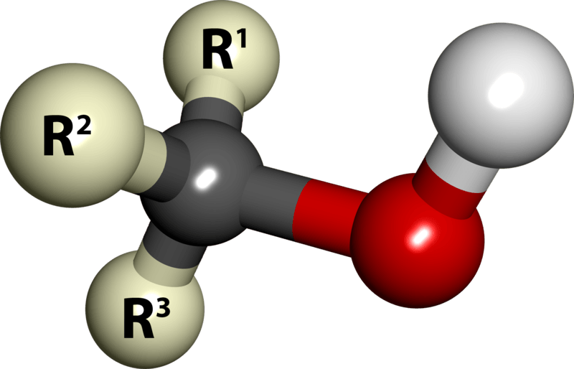

**How is the course assessed?**

The course is assessed by three written exams at the end of Year 13. All exam components assess content from all five modules. The three exams are:

* Periodic table, elements and physical chemistry -100 marks, 2 hour 15 minute written exam
* Synthesis and analytical techniques -100 marks, 2 hour 15 minute written exam
* Unified chemistry - 70 marks, 1 hour 30 minute written exam

There is also a separate qualification of *Practical endorsement in chemistry*, assessed internally through practical work and reported separately to the A level grade.

**The Future?**

Success on this course could see you move on to study for a degree course in related subjects such as chemistry, biochemistry, chemical engineering, pharmaceutical science or nursing. Students have gone on to a range of Higher Education courses including Liverpool (Medicine), St George’s (Mediucine), King’s College London (Biochemistry), Nottingham (Zoology, Medicinal and Biological Chemistry), Leicester (Biochemistry). Related careers include sports science, forensic science, teaching and science journalism.

**Exam Board: OCR**

**Staff Contact: Miss Namuk**

**Economics A**

**A Level**

What qualifications do I need?

Five GCSEs Grade 9-4. Grade 5/6 in English and Maths. %/6 in Business and/ or Economics if previously studied.

**What does the course involve?**

The aim of the course is to develop an interest in, and enthusiasm for, the subject. This includes appreciating the contribution of economics to the understanding of the wider economic and social environment. Further to develop an understanding of a range of concepts and an ability to use those concepts in a variety of different contexts. Also to learn the use an enquiring, critical and thoughtful approach to the study of economics and develop an ability to think as an economist. To appreciate and to understand that economic behaviour can be studied from a range of perspectives. The ultimate goal is to develop analytical and quantitative skills, together with qualities and attitudes that will equip you for the challenges, opportunities and responsibilities of adult and working life.

**What does the course involve?**

This course consists of four themes taught over two years.

*Year 12*

Theme 1: Introduction to markets and market failure

Theme 2: The UK economy – performance and policies

*Year 13*

Theme 3: Business behaviour and the labour market

Theme 4: A global perspective

**How is the course assessed?**

A Level Economics A, comprises of three exams all of which are 2 hours long and out of 100 marks.

Paper 1: Markets and business behaviour (35% of the total qualification)

Each question is set in a context, drawing on topics from across Themes 1 and 3.

Paper 2: The national and global economy (35% of the total qualification)

Each question is set in a context, drawing on topics from across Themes 2 and 4.

Paper 3: Microeconomics and Macroeconomics (30% of the total qualification)

Each question is set in a context, drawing on topics from across

Themes 1, 2, 3 and 4.

**The Future?**

This qualification will provide you with a solid foundation for studies at higher education in Economics or Business related subjects. You may also choose to study International Business or a Business or Management degree. Economics students can also progress into a wide range of careers in industry, commerce, finance and the civil service.

**Exam Board:**

Edexcel A Level Economics A

**Staff Contact: Mr Middleton and Mr Atkins**

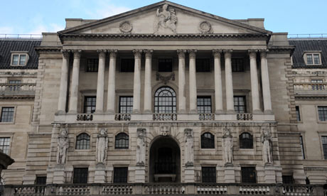

**English Language / Linguistics A Level**

**What qualifications do I need to begin the course?**

Five GCSEs Grade 9-4.You will also need a grade 5 or higher in English Language GCSE.

**What does the course involve?**

With exciting text- and data-based sources of language, the specification introduces the study of English in its various forms and contexts, with the concepts and methods appropriate for the analysis of language underpinning all elements of the course. Offering clear skills progression from GCSE, this course allows students to build on the skills already gained and prepare for their next steps.

The variety of assessment styles used, such as data analysis, discursive essays, directed writing, original writing and research-based investigative writing, allows students to develop a wide range of skills. These include critical reading, data analysis, evaluation, the ability to develop and sustain arguments and a number of different writing skills which are invaluable for both further study and

future employment.

**How is the course assessed?**

**Paper 1: Language, the Individual and Society**

• Textual variations and representations

• Children's language development (0-11 years)

• Methods of language analysis are integrated into the activities

**Assessed**

• written exam: 2 hours 30 minutes

• 100 marks

• 40% of A-level

**Questions**

**Section A - Textual Variations and Representations**

Two texts (one contemporary and one older text) linked by topic or theme.

• A question requiring analysis of one text (25 marks)

• A question requiring analysis of a second text (25 marks)

• A question requiring comparison of the two texts (20 marks)

**Section B - Children's Language Development**

A discursive essay on children’s language development, with a choice of two questions where the

data provided will focus on spoken, written or multimodal language (30 marks)

**Paper 2: Language Diversity and Change**

**What's assessed**

• Language diversity and change

• Language discourses

• Writing skills

• Methods of language analysis are integrated into the activities

**Assessed**

• written exam: 2 hours 30 minutes

• 100 marks

• 40% of A-level

**Questions**

**Section A - Diversity and Change**

One question from a choice of two:

**Either:** an evaluative essay on language diversity (30 marks)

**Or:** an evaluative essay on language change (30 marks)

**Section B - Language Discourses**

Two texts about a topic linked to the study of diversity and change.

• A question requiring analysis of how the texts use language to present ideas, attitudes and opinions (40 marks)

• A directed writing task linked to the same topic and the ideas in the texts (30 marks)

**Non-exam assessment: Language in Action**

**What's assessed**

• Language Investigation

• Original Writing

• Methods of language analysis are integrated into the activities

**Assessed**

• Word count: 3,500

• 100 marks

• 20% of A-level

• Assessed by teachers

• Moderated by AQA

**Tasks**

Students produce:

• a language investigation (2,000 words excluding data)

• a piece of original writing and commentary (1,500 words total)

**The future?**

This course is particularly suitable for those students who wish to study English Language, Linguistics or English Studies in Higher Education

**Exam Board: AQA**

**Staff Contact: Mr N Foad**



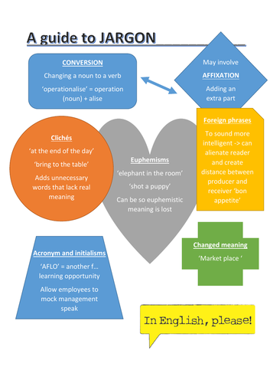

**English Literature A Level**

**What qualifications do I need to begin the course?**

Five GCSEs Grade 9-4.You will also need a grade 5 or higher in English Language or English Literature GCSE.

**What does the course involve?**

The subject encompasses a relevant, engaging and up-to-date

specification that approaches the reading and study of literature through the lens of genre and theory, encouraging the independent study of a range of texts within a shared context, giving logic and meaning to the way that texts are grouped for study.

The variety of assessment styles used, such as passage-based questions, unseen material, single text questions, multiple text questions, open- and closed-book approaches, allows students to develop a wide range of skills, such as the ability to read critically, analyse, evaluate and undertake independent research which are valuable for both further study and future employment.

**How is the course assessed?**

**Paper 1: Literary genres**

Choice of two options

Option 1A: Aspects of tragedy

Option 1B: Aspects of comedy

Study of three texts: one Shakespeare text; a second drama text and one further text, of which

one must be written pre-1900

**Assessed**

• written exam: 2 hours 30 minutes

• closed book

• 75 marks

• 40% of A-level

**Questions**

**Section A:** One passage-based question on set Shakespeare text (25 marks)

**Section B:** One essay question on set Shakespeare text (25 marks)

Section C: One essay question linking two texts (25 marks)

**Paper 2: Texts and genres**

Choice of two options

Option 2A: Elements of crime writing

Option 2B: Elements of political and social protest writing

Study of three texts: one post-2000 prose text; one poetry and one further text, one of which must be written pre-1900 exam will include an unseen passage.

**Assessed**

• written exam: 3 hours

• open book

• 75 marks

• 40% of A-level

**Questions**

**Section A:** One compulsory question on an unseen passage (25 marks)

**Section B:** One essay question on set text (25 marks)

**Section C:** One essay question which connects two texts (25 marks)

**Non-exam assessment: Theory and independence**

Study of two texts: one poetry and one prose text, informed by study of the Critical Anthology

Two essays of 1250 -1500 words, each responding to a different text and linking to a different aspect of the Critical Anthology

One essay can be re-creative. The re-creative piece will be accompanied by a commentary.

**Assessed**

• 50 marks

• 20% of A-level

• assessed by teachers

• moderated by AQA

**The Future?**

The analytical nature of this course means that it is an excellent choice for a wide range of careers. It is particularly suited to students who are interested in careers in media, public relations, publishing, law, politics and education, as well as learners who may wish to pursue careers as writers.

**Exam Board: AQA**

**Staff Contact: Mr N Foad**

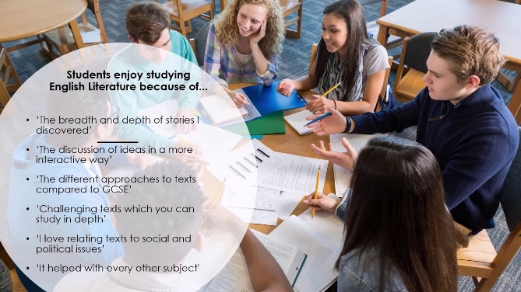

**Film Studies A Level**



The critical study of films as texts and of their contexts is a highly transferable academic skill, which develops a range of other skills from literacy to ICT. If you are passionate about film, you can now turn your enthusiasm to your academic advantage. Film is part of the largest export of the United States of America’s entertainment industries. This A Level is definitely for the film buff.

**What qualifications do I need to begin the course?**

A minimum of 5 GCSEs at grade 9-4, with a grade 6 or equivalent specifically in English Literature.

**What you will be studying on the course**

This course will extend your knowledge by introducing you to a wide range of films, cover technical knowledge of filmmaking techniques, consider the academic discipline of film theory and criticism, offer you an opportunity to be creative with practical work, study the processes and practices of the film industry and enhance your knowledge and appreciation of film.

**Topics of study include:**

• Spectatorship studies – how and why audiences respond to film

• Exploring film form – mise-en-scène, cinematography, editing, sound, narrative performance and genre

• Practical work

• US and UK film production, distribution and exhibition

• British cinema study

• Production work, such as short film-making or screenwriting

• Study of emotional response to popular cinema looking at how and why film generates an emotional response

• Contemporary world cinema

**Method of Assessment**

Component 1: Varieties in Film and Film Making

35% External Assessment

2 ½ hours written paper.

Component 2: Global Film Making Perspective

35% External Assessment

2 ½ hours written paper.

Component 3: Production of a Short Film

30% Internal Assessment

**How will the course benefit you?**

This may well indicate a future academic or career direction. Film Studies has been studied at international universities since the 1960s and can lead to a variety of careers on both sides of the camera, including writing and journalism.

Complementary Courses

* English Literature
* English Language
* History
* Media Studies
* Sociology
* Art
* Music

**Exam Board: Eduqas**

**Staff Contact: Mr T. Jackson**

**Geography A Level**

**What qualifications do I need to begin the course?**

Five GCSEs Grade 9-4 including a grade 6 in Geography.

**What does the course involve and how is it assessed?**

**Component 1: Physical Geography**

**Section A:**

Water and carbon cycles

**Section B**

\***Hot desert environments and their margins** OR Coastal systems and landscapes.

**Section C**

\***Hazards** OR Ecosystems under stress OR Cold environments.

Assessed in a written exam of 2 hours 30 minutes

Component 1 is worth 40% of the A Level.

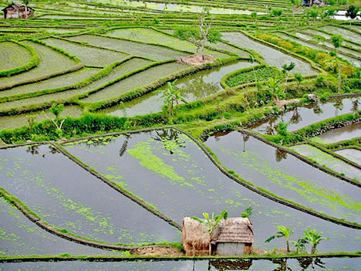

**\*current course target with these options.**

**Component 2: Human Geography**

**Section A:**

Global Systems and global governance.

**Section B**

Changing places.

**Section C:**

Contemporary urban environments OR \***Population and the environment** OR Re-source security.

Assessed in a written exam of 2 hours 30 minutes.

Component 2 is worth 40% of the A Level

**Component 3: Investigation**

Students complete an individual investigation which must include data collected in the field on a compulsory residential trip. The individual investigation must be based on a question or issue defined and developed by the student relating to any part of the specification content.

Assessed in a 3000-4000 word report worth 20% of the A Level.

Marked by teachers in school.

**Exam Board: AQA**

**Staff Contact: Mr Wood**

**Government and Politics A Level**

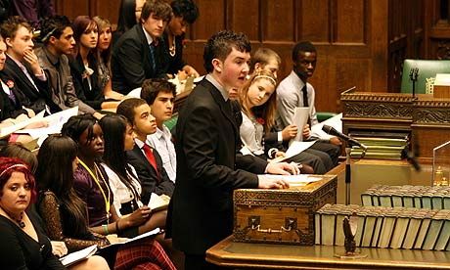

**What qualifications do I need to begin the course?**

A minimum of 5 GCSEs at grade 9-4, with a grade 6 or equivalent specifically in English language.

**What does the course involve?**

**Year 12: Government and politics of the UK**

Topics include:

* the British Constitution;
* Parliament;
* The Prime Minister and Cabinet;
* The Judiciary and the Court system;
* Democracy and Participation;
* Elections and Referendums;
* Political Parties;
* Pressure Groups, and
* The European Union.

**Year 13: The Government of the USA/The Politics of the USA.**

Topics include:

* the Constitution of the USA;
* Congress;
* The Presidency;
* The Judiciary and the Supreme Court;
* The Electoral Process and Direct Democracy;
* Political Parties;
* Pressure Groups;
* Civil Rights.

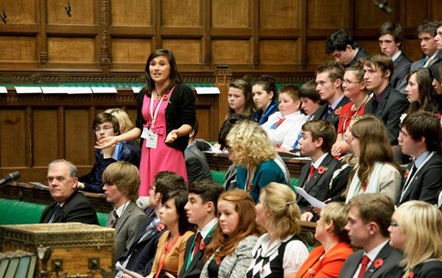

In addition, students will also learn about a variety of ideologies, including Socialism, Conservatism, Liberalism, Feminism and Anarchism.

Staff will adopt a variety of approaches to course content. A typical week’s work might include an introductory lesson followed by a DVD, supportive handouts and group discussion sessions. Thus learners must show a strong interest in current affairs, and be willing to participate in class discussions, debate and the active learning situation.

**How is the course assessed?**

Students sit 3 exam papers at the end of Year 13. All papers are 2 hours long. There is no coursework required with this subject.

**The Future?**

Government and Politics is compatible with any combination of A/AS level subjects, both arts and sciences. It is highly acceptable for university and

college entrance, and for direct entry in careers of any field Students have gone on to study at a number of universities, including Oxford University (Politics and History), Sheffield and Glasgow (Politics), Leeds and Southampton (International History and Politics) and Winchester (Politics and Global Studies).

**Exam Board: EdExcel**

**Staff Contact: Mr Lill**

**Health & Social Care**

**BTEC Level 3 Extended Certificate**

# What is a BTEC Level 3 extended Certificate?

# Edexcel BTEC Level 3 Extended Certificate in Health and Social Care is equivalent to one A level qualification that is studied over two years (Years 12-13). It provides a specialist work-related qualification. You will gain the knowledge, understanding and skills necessary to prepare you for employment.

# What qualifications do I need to begin the course?

Five GCSEs 9-4, Level 2 BTEC qualifications are accepted and students should aim to get a merit or distinction.

**What will you study?**

The Edexcel BTEC Level 3 Extended Certificate in Health and Social Care consists of **two** written exams as well as **two** written assignments, one mandatory and one optional. Combined the two assignments and two exams total 360 guided learning hours (GLH).

**Written Exam:**

1. Human Lifespan and Development (90 GLH)

2. Working in Health and Social care (120 GLH)

**Mandatory units:**

1. Meeting Individual Care and Support Needs (90 GLH)

**Examples of Optional units (60 GLH):**

* Sociological Perspectives
* Psychological Perspectives
* Supporting Individuals with Individuals with Additional Needs
* Physiological Disorders

**How is the course assessed?**

You will be assessed internally through planned written assessments. There will be strict deadlines to meet for the submission of work. You will also be assessed externally and will sit two, 90 minute, exams.

**The Future?**

The Health and Social care sectors encompasses staff involved in direct care, e.g. nursing, as well as specialists such as health scientists, technicians, support staff, supervisors and managers. Job opportunities exist in the statutory, private and voluntary provision of care services. The BTEC Level 3 Extended Certificate in Health andSocial Care isdesigned as a standalone qualification that provides learners with knowledge and understanding of the health and social care sectors, and specialist knowledge and understanding according to the units studied.

*“4 out of 5 BTEC students who progressed into employment considered BTEC as an important stepping stone towards their dream job”*

**Exam Board: Edexcel**

# Staff Contact: Ms. D Aram

**History A Level**

**What qualifications do I need to begin the course?**

It is essential that you have a lively and enquiring mind, coupled with a passion for History. An interest in politics and current affairs is also required. You must possess a desire to explore new ideas and a willingness to communicate your ideas effectively both written and verbal. You should have at least 5 GCSEs at grades 9-4 or equivalent including English Language at grade 5 and a grade 6 in GCSE History. However, if students do not meet the entrance requirements their application will be considered on individual merit, taking into account previous commitment to study, their record of behavior in school and work habits; this will be at the discretion of the Head of Department.

**What does the course involve?**

The History course involves students studying a variety of periods that challenge their understanding of societies, cultures and political ideologies. Students will be required to debate ideas, engage actively within the lessons and complete essays. It is designed to help students become independent and life-long learners. There is a heavy emphasis on reading which students will be expected to do on a continual basis in order to develop a deeper understanding of the areas they are studying. By the end of the course they will have learned to evaluate and analyse many sources, work both independently and as a team, develop opinions on historical events and personalities and communicate complex historical concepts effectively.

**Year 12**

**Unit 1 – British period study and enquiry: Britain 1930 – 1997 (Enquiry Topic: Churchill 1930 – 1951)**

Students will study the following key topics

1. Conservative domination 1951 – 1964
2. Labour and Conservative governments 1964 – 1979
3. Thatcher and the end of consensus 1979 – 1997
4. Britain’s position in the world 1951 – 1997

For the enquiry on Winston Churchill, students will study the following key topics

1. Churchill’s view of events 1929 – 1934
2. Churchill’s as wartime Prime Minister
3. Churchill and international diplomacy 1939 - 1951

**Written exam of 1 hour and 30 minutes**

**Unit 2 – Non-British period study:** **The French Revolution and the rule of Napoleon 1774-1815**

Students will study the following key topics

1. The causes of the French Revolution from 1774 and the events of 1789
2. The Revolution from October 1789 to the Directory 1795
3. Napoleon Bonaparte to 1807
4. The decline and fall of Napoleon 1807 – 1815

**Written exam of 1 hour**

**Year 13**

**Unit 3 – Thematic study and Historical Interpretations:** **Russia and its Rulers 1855 – 1964**

Students will study the following key topics

1. The nature of government
2. The impact of dictatorial regimes on the economy and society of the Russian Empire and the USSR
3. The impact of war and revolution on the development of the Russian Empire and the USSR
4. Russia: Empire, nationalities and the satellite states

**Written exam of 2 hours and 30 minutes**

**Unit 4 – Coursework: International Relations 1890-1941**

Students will undertake an independent study of the following key areas

1.) The causes and nature of the First World War

2.) The Paris Peace Conference, the League of Nations, and international diplomacy 1919-1935

3.) Dictators and Appeasers in Europe 1929-1941

4.) The Far East 1918-1941

Submitted essay of 3,000 to 4,000 words including the analysis of a variety of Historical sources

**The Future?**

A-Level History continues to be held in high esteem and is valued by employers and universities alike because it teaches the skills of interpretation, analysis, independent research, and decision making. Students who study History have access to a wide range of careers including Politics, Law, Education, Business and Finance, Journalism, Heritage Management, Sports Management, Media and the Arts. Many past students have continued with history to degree level choosing courses at Russell Group universities such as York and Southampton.

**Exam Board: OCR**

**Staff Contact: Miss Maley**

**Information Technology BTEC Level 3**

**What qualifications do I need to begin the course?**

Students who have completed an IT related course at key stage 4 need to have achieved a Grade 4 or above equivalent. For example, students who have completed BTEC or Cambridge National need to have achieved a Level 2 Pass or above. Any student who did not complete an IT related course at key Stage 4 will also be considered. You will need to have achieved at least grades 4 or above or equivalent in Mathematics and English GCSE.



**What does the course involve?**

There are four units. Units 1 to 3 are Mandatory and a fourth one is to be chosen by the teachers.

**Unit 1: Information Technology Systems**. You will learn about computer hardware and software, how they relate to each other and about user interaction within this relationship. You will examine the issues related to the use of IT systems and the impact of them on the world around us. You will gain an understanding of how to effectively select and use appropriate IT systems.

**Unit 2: Creating Systems to Manage Information.** This unit is all about database management. You will learn how to design an efficient data structure for given situations and then create a fully working database solution.

**Unit 3: Using Social Media in Business.** You will explore and analyse various social media websites and identify the benefits and pitfalls of their use. You will create a plan for the use of social media in a business setting to achieve specific busness objectives.

**Last Unit:** To be chosen from Unit 5 (Data Modelling) or Unit 6 (Website Development). As a centre we are planning to deliver the website development unit.

We are also hoping to run some additional units in Programming and either Apps or Games development for suitable candidates (possibly as part of the sixth form enrichment program). These additional units would allow students to achieve the Foundation Diploma (equivalent to 1.5 A-levels).

**How is the course assessed?**

Units 1 is assessed by a two hour written exam and represents one third of the overall grade. It is assessed externally. Unit 2 is also assessed externally in the form of a five hour practial exam. Unit 3 is assessed by your teacher and will be assignment based. Units 2 and 3 represent twenty five percent each of the total grade. Unit 6 is also assessed by your teacher and represents one sixth of the overall grade.

**The Future?**

This course has been design in close collaboration with experts from professional bodies, businesses and universities. All units provide learners with a synoptic and fundamental understanding of IT which support progression to higher education courses in, or employment within IT.

**Exam Board: Edexcel**

**Staff Contact: Mrs Nsiah**

**Law A Level**

**What qualifications do I need to begin the course?**

A minimum of 5 GCSEs grade 9-4 or equivalent, with a grade 6 specifically in English Language.

**What does the course involve?**

An A-Level Law student will be challenged to apply and develop their analytical ability, decision making, critical thinking and problem-solving skills.

You will be taken on a journey to understand how law functions in society, the ways laws develop, and how laws incorporate the ideas of justice and morality.

Students will learn about the distinctions between criminal and civil courts, including the many roles and duties that exist within each, such as the role of jurors in a criminal trial.

The criminal law unit enables students to discover a wealth of case law and statutes (laws passed by Parliament), focusing on offences against the person, and offences against property. The available defences for certain criminal charges also offer a fascinating insight for students.

Subsequently, tort law explores civil issues such as liability, and negligence of individuals or groups of people, causing damage to another, either physically or financially.

**How is the course assessed?**

Paper 1 (Year 12):

The nature of law and the English legal system (25 marks out of 100)

Criminal law (75 marks out of 100)

Paper 2 (Year 12):

The nature of law and the English legal system (25 marks out of 100)

Tort law (75 marks out of 100)

Paper 3 (Year 13):

Law of contract (75 marks out of 100)

The nature of law and the English legal system (25 marks out of 100)

OR

Human rights (75 marks out of 100)

The nature of law and the English legal system (25 marks out of 100)

*choice for Paper 3 to be decided in due course, and will be studied in Year 13

Each paper is assessed as follows:

• Written exam: 2 hours

• 100 marks

• 33% of A-Level

• Students will face a combination of multiple choice, short answer and extended writing questions

**The future?**

Studying law will open up many potential avenues for you, whether you intend to study law at university

or not. You may want to pursue a legal career as a solicitor; dealing

with a range of issues e.g. family law, or perhaps aspire to be a barrister in

a criminal court. You may be inspired to delve deeper into the world of local or national politics.

In terms of subjects to complement your study of Law at A-Level, perhaps consider English Language/Literature, Government and Politics, Sociology, R.E et al

**Exam Board: AQA**

**Staff Contact: Mr A Chandler**

**Mathematics**

**A Level**

**What qualifications do I need to begin the course?**

We require a minimum grade 7 in the Maths GCSE higher paper **OR** a 6 in the same paper and passing an internal test.

**What does the course involve?**

The course consists of 3 exams. 2 or which are Pure Mathematics and the third which is applied (a mix of Statistics and Mechanics).

**Year 12:**

You will be studying the first section of content for Pure Mathematics. This is the AS part of the course. Alongside this you will begin your studies within Statistics and Mechanics.

**Year 13:**

You will cover the remainder 50% of the course including the higher Pure Mathematics and applied sections.

**Pure Mathematics** is about the theoretical aspects of the subject. You will learn about logarithms, integration and differentiation as well as consolidating and extending your knowledge of GCSE topics like vectors.

**Mechanics** is an area of applied mathematics that focusses on motion and forces producing motion. You will be studying about kinematics, collisions and moments.

**Statistics** is an area of applied mathematics that focusses on collecting and analysing data. You will further your study of probability as well as look at statistical distributions and hypothesis testing.

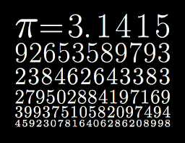

**How is the course assessed?**

There will be 3 papers at the end of year 13. These will consist of 2 Pure Mathematics papers each lasting 2 hours. The third paper will be the applied paper assessing your knowledge on Mechanics and Statistics which will last 2 hours.

**The Future?**

The Advanced Level is highly regarded by many employers and gives access to a wide range of varied employment opportunities. An A level in Mathematics is essential to anybody hoping to study any science at university, including engineering or one of the medical sciences, as well as mathematics or computing courses. It is also useful for anyone considering a career in the financial sector.

**Exam Board: Edexcel**

**Staff Contact: Ms Allanson and Mr Campos**

**Further Mathematics A Level**

**What qualifications do I need to begin the course?**

We highly recommend a minimum grade 7 in the higher paper, Maths GCSE.

**What does the course involve?**

The course consists of 4 exams. 2 of which are Core Pure Mathematics and the third and fourth are Further Mathematics options 1&2.

**Year 12:**

You will be studying A Level Mathematics (Pure Mathematics 1/2, Statistics 1/2, Mechanics 1/2).

**Year 13:**

You will be studying A Level Further Mathematics (Core Pure Mathematics and Further Pure Maths options).

**Core Pure Mathematics** is about the theoretical aspects of the subject. You will learn about proof, complex numbers, matrices, further algebra and functions, further calculus, further vectors, polar coordinates, hyperbolic functions, differential equation.

**Further Mathematics Option 1.**  Students will have an option to choose any one of the four choices: *Further Pure Mathematics 1, Further Statistics, Further Mechanics 1, Decision Mathematics 1.*

**Further Mathematics Option 2.** Students will have an option to choose any one of the seven choices: Further Pure Mathematics 2, Further Statistics 1, Further Mechanics 1, Decision Mathematics 1, Further Statistics 2, Further Mechanics 2, Decision Mathematics 2.

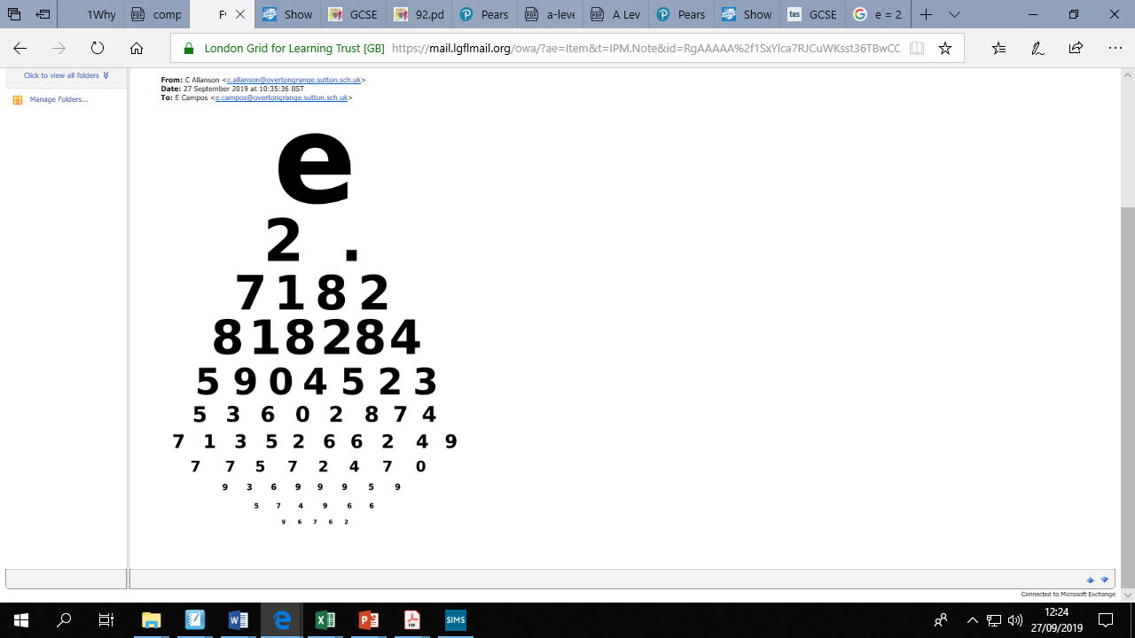

**How is the course assessed?**

There will be 4 papers at the end of year 13. These will consist of 2 Core Pure Mathematics papers each lasting 1.5 hours. The third and fourth papers will be the Further Mathematics options 1 & 2 which will last 1.5 hours each.

**The Future?**

Further Mathematics is a versatile qualification that is well-respected by universities and employers alike. Men and women who have good mathematical skills and qualifications tend to pursue careers that are rewarding and interesting as well as being highly paid. Mathematics opens up doors to a wide range of career choices. There is a significant demand by employers within science, engineering and manufacturing employers and having A level Mathematics and Further Mathematics makes you a very desirable candidate for such a career path.

**Exam Board: Edexcel**

**Staff Contact: Ms Allanson and Mr Campos**

**Media Studies**

**A Level**

**What qualifications do I need to begin the course?**

Five GCSEs at grade 9-4. At least a grade 5 or equivalent in GCSE English. If GCSE Media Studies was taken, a 5/6 or higher will also be required.

**What does the course involve?**

Media Studies A-level involves learning about a whole range of different media platforms and content both historical and contemporary, using examples from both British and American media, as well as examples from the rest of the world such as European cinema etc.

Students will be taught about film, television, advertising, magazines, newspapers, music videos, video games, social media and other online media, apps, radio and more. Students will be learning to analyse and deconstruct real media products so that they can better understand the world around them and develop their literacy as well as their analytical skills.

As well as the theoretical side to the course, students will also be learning and developing a range of practical skills including learning how to use digital video cameras, photographic equipment, digital photo editing and print design (using Pixelmator), digital video editing (using Final Cut Express), blogging, vlogging and a wide variety of other media technologies such as Prezi, Scribd, You Tube etc.

**How is the course assessed?**

The course is 70% exam (2 exam papers) and 30% coursework (practical production).

The two exams will cover a whole variety of topics including the 4 main Media Studies key concepts:

**Media Language** – The codes and conventions of different media products, the structure of media products including aspects such as narrative, intertextuality, genre, etc. Semniotics and symbolic meaning will be discussed as well as theorists such as Barthes, Neale, & Todorov.

**Representation** – stereotyping and moral panics, the ways in which gender, ethnicity, sexuality, age, disability nationality, class are represented in media products, the ways in which representations are constructed and why, realism, the effect of social policy and historical context on representations, and theorists such as Gauntlett, Hall and Gilroy will be studied.

**Audiences** – targeting and engaging audiences, demographics, audience participation, the power and role of audiences in the digital age, and theorists such as Gerbner and Hall will be studied.

**Institutions & Industries** – Ownership, control, competition of business, conglomerates, globalisation, the effects of digital developments on companies, diversification, production, distribution and marketing, and theorists such as Curran & Seaton will be studied

As well as the exam units, students will take part in Production tasks for coursework.

**Production** - The coursework unit will involve students planning and producing between 1 and 3 pieces of practical work. Coursework tasks change each year as dictated by exam board briefs. Examples of possible products students might be asked to produce include a music video, a TV sequence, a film trailer, a documentary, a website, a magazine, a CD cover, etc

**The future?**

There is a clear progression to university courses involving media or other creative subjects such as Media Studies, Film Studies, Performing Arts, Drama, Photography, Journalism, ICT, Advertising etc. The A-level will also be useful for any course that requires research and analytical skills as well as any course that requires you to demonstrate extended writing, and an ability to debate ideas and carry out research. As your production skills will be tested and developed on the course, it also prepares you for roles within the industry where hands-on practical experience is essential. Many jobs now require a high degree of media literacy, particularly using digital technologies so this will benefit students undergoing any technical or communications role within a company. In addition to this, it will also develop students' ability to work to industry briefs and work in and lead teams.

Students have, in the past, gone on to study related courses at, among others, the universities of Southampton (Film Studies), Brighton (Journalism), Surrey (Media Studies), Kent (Multimedia Technology), Staffordshire (Film Production), Bournemouth (Multimedia Journalism, TV Production, Animation, Advertising & Marketing), University for the Creative Arts (Digital Screen Arts) and St Mary’s (Media Arts).

**Exam Board: Eduqas**

**Staff Contact: Mr T Jackson**

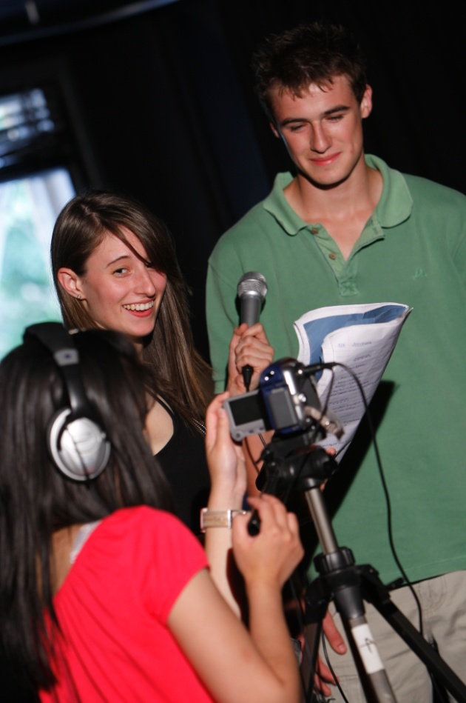

**Modern Foreign Languages**

**French / German /Spanish** **A Level**

**What qualifications do I need to begin the course?**

Five GCSEs at 9 – 4. In addition, you will need at least a grade 6 in GCSE French / German / Spanish in order to continue with an A-level in your chosen language.

**What does the course involve?**

Studying a language not only gives you the ability to write and converse in a foreign tongue, you also learn about the structure of language, syntax and grammar and how these interact with your own natural language. This translates to a greater understanding of English, which can be beneficial for writing, reading and interpreting our written language. You also benefit from learning about different cultural aspects and you will have the opportunity to express your opinions on a variety of topics and discuss issues in depth.

**A Level Topics are:**

Social Issues and Trends:

* Changes in the family
* Cyber Society
* Youth Culture
* Political Systems
* Artistic Culture
* Music and Cinema
* Study of a film and a novel

**How is the course assessed?**

AL – unit 1: Listening, reading and translation

1 hour 50 minutes

AL – unit 2: Written response to a film or a book plus a further translation.

2 hours 40 minutes

AL – unit 3: Speaking exam

21-23 minutes

(discussion on a chosen theme, plus further discussions and a presentation)

**The Future?**

There are a number of extremely interesting courses in Higher Education that include studying a language. Many learners combine the study of a language with other subjects such as History, Law, Economics, Politics and Maths, which will enable you to live abroad for a year.

Having a foreign language skill is a distinct advantage in many careers. Here are some quotes from employers:

*‘Employees with language skills are definitely more marketable and have a greater worth in the labour market.’*

**Bob Shankly, HR director, BMW.**

*‘The fact is businesses are looking for employees with language skills. As globalisation accelerates, the ability to communicate internationally is becoming a pre-requisite for success.’*

**Miles Templeman, Director General, Institute of Directors.**

*‘Multi-lingualism is an indicator of general mental ability and an internationalist outlook.’*

**Chief Learning Manager, Deutsche Bank**

Did you know that:

* 75% of the world’s population don’t speak any English at all.
* Only 6% of the world’s population speak English as a first language.
* One in five exporting companies say they are losing trade because of language and cultural barriers.
* 72% of UK trade is with countriesthat do not haveEnglish as their first language.

**Exam Board: AQA**

**Staff Contact: D Atchison**

**Philosophy and Ethics (Religious Studies)**

**A Level**

**What qualifications do I need to begin the course?**

Five GCSEs at 9-4. Ideally to study Religious Studies you will achieve a grade 5/6 in GCSE RE and a 5/6 or equivalent in English, however, we may consider you if you achieve a grade 5 but this will be on an individual basis.

**What does the course involve?**

The course involves the study of three disciplines: Philosophy, Ethics and the development in Religious thought. Unlike Philosophy and Ethics courses at GCSE, the A level concentrates on studying, debating and enquiring into issues and questions such as:

* *If life is no more than DNA reproducing itself, isn’t it impossible for there to be an afterlife?*
* *Do we have a duty to fight for our country?*
* *If our life is determined before we are born, how can we be held responsible for our bad actions?*

You will be expected to analyse and evaluate some of the greatest philosophical arguments that have been debated and contested over thousands of years. Can you outthink the greatest thinkers?

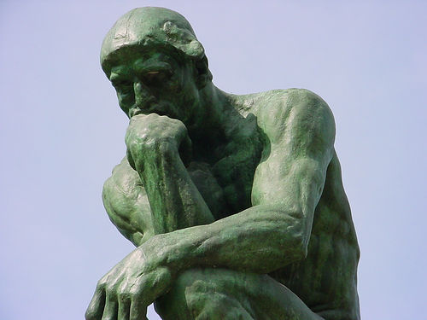

**What will I study?**

**Module 1 - Philosophy**

Plato – the analogy of the cave. You will discuss critically the validity of the analogy.

Aristotle – ideas about cause and purpose in relation to God.

The concept of God as a creator – you will assess the way God is presented in the Bible and in imagery. You will look at the concepts of omnipotence, omniscience and omnipresence. To critically discuss The Goodness of God.

Arguments for the existence of God and the problem of Evil.

**Module 2 – Ethics**

Ethical theories.

You will critically assess the strengths and weaknesses of Natural Law, Kantian Ethics, Utilitarianism and Christian Ethics.

How the above theories can be applied to:

- abortion and the right to a child

- euthanasia

- genetic engineering

- war and peace

**Module 3- Development in Religious thought.**

You will study: religious beliefs, values and teachings, their interconnections and how they vary historically and in the contemporary world, sources of religious wisdom and authority, practices which shape and express religious identity, and how these vary within a tradition, significant social and historical developments in theology and religious thought and key themes related to the relationship between religion and society.

**How is the course assessed?**

Students sit three 2-hour papers. One for each module in year 13.

There is no coursework component to this specification, but in-depth studies and extended projected will be completed throughout the course to help students develop the skills and knowledge base required for the examinations.

**Am I right for the course?**

Do you ask ‘why?’ when told to tidy your room or when given an instruction in class? Do you often think ‘what’s the point?’ when given a task to do? Do you ever wonder if we are really alive or if we are dreaming? If so, you are searching for answers too and would be a perfect candidate to take Philosophy and Ethics.

**What skills will I learn?**

Studying Philosophy and Ethics helps you:

* Analyse and construct sound arguments
* Distinguish fine differences between views and fine common ground
* Present ideas convincingly through well-constructed, systematic arguments
* Write clearly and persuasively
* Generate ideas and come up with solutions to problems
* Team working and communication skills
* Empathy and the ability to understand people and take on board others’ views
* The ability to work methodically and accurately
* Independence of mind and the ability to think for yourself

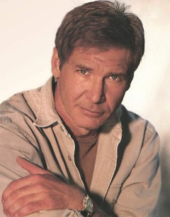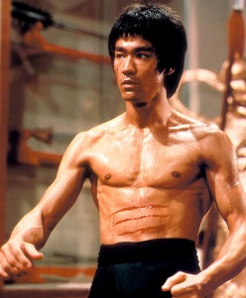

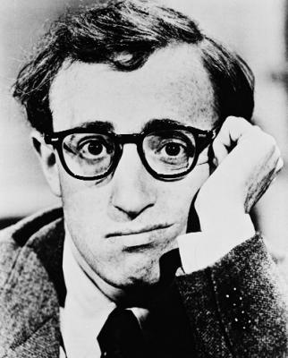

**The Future?**

The skills of evaluation and analysis that Philosophy and Ethics teaches you are applicable to almost any walk of life. It is not just about what others think; it is about learning to think for yourself. As a result, Philosophy and Ethics is widely accepted as an entry qualification by universities and higher education courses.

According to AGCAS – the Association of Graduate Careers Advisory Service, RE/Theology gradates go into a wide range of careers. However, they, and employers, feel that it particularly prepares students for the following careers: Financial Services, Legal Sector (Law), Medicine, Politics, Consultancy, Civil Service, Journalism, Media Sector, Education Sector, Computer Science, Business, NHS, Publishing Sector, Social Care Sector, Voluntary Sector, Social and Pastoral Care and Community work.

And that’s not all…

These skills will benefit you in any area that involves working with others, showing initiative or thinking for yourself…that’s just about anything!

**Exam Board: OCR**

**Staff Contact: Miss Barraclough**

**Miss Treagus**

**Miss Dean**

**Physical Education A Level**

**What qualifications do I need to begin the course?**

A minimum of a 5 in GCSE PE. It is also recommended that students have a grade 5/6 in Additional or Triple Science. It is a requirement that you also belong to a Sports Club/Team outside of school.

**What does the course involve?**

**Applied anatomy and physiology**

* Muscular and skeletal system
* Cardiovascular systems
* Neuro-muscular system
* Energy systems

**Exercise physiology**

* Diet and nutrition
* Preparation and training methods
* Injury prevention and rehabilitation
* Motion and Biomechanics

**Skill acquisition**

* Coaching and performing
* Classification and transfer of skill
* Learning theories
* Practice
* Guidance and feedback
* Memory models

**Sport psychology**

* Factors that influence an individual in sport
* Group and team dynamics
* Goal setting
* Attribution theory
* Confidence and self-efficacy
* Leadership

**Sport and society**

* Development of modern day sport
* Globalisation of sport
* Commercialisation of sport
* Ethics and deviance in sport
* Sport and the media
* Talent identification
* Health of the nation

**Practical Performance**

* Perform in one physical activity as either a player/performer or coach.
* Perform a range of skills and techniques in their chosen sport.

**Performance analysis and Development Programme**

* Investigate one physiological component and either a technical or tactical component.
* Evaluate the effectiveness of a performer.
* Produce an evaluation to demonstrate strengths and weaknesses and areas for development.

**How is the course assessed?**

* Minimum of three written examinations **(70%)** comprising of short, long answer and extended writing questions.
* Performance or coaching role and Performance Analysis and Development **(30%)**

**Exam Board: OCR**

**Staff Contact: Mr Potter**

**Physics A Level**

**What qualifications do I need to begin the course?**

A minimum five GCSEs at 9-4. A minimum of grade 6/6 in GCSE (double) Science or , for Triple Science students, a grade 6 in Physics is required with a minimum of one grade 5 and one grade 6 in Biology and Chemistry. A grade 6 in Mathematics is also required.

**What does the course involve?**

This course consists of core content and an optional module taught over two years:

**Year 12**

The core content covers five sections:

Section 1: Measurements and errors

Section 2: Particles and radiation

Section 3: Waves

Section 4: Mechanics and materials

Section 5: Electricity

**Year 13**

The core content covers three sections:

Section 6: Further mechanics and thermal physics

Section 7: Fields and their consequences

Section 8: Nuclear physics

Optional Section: Astrophysics

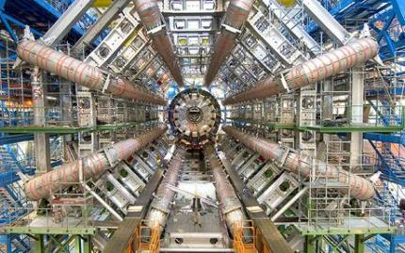

**How is the course assessed?**

The course is assessed by three written exams at the end of Year 13. The three exams are:

* Paper 1 (Mostly Year 1 content) – 85 marks, 2 hour written exam consisting of long and short answer questions and a multiple choice section
* Paper 2 (mostly Year 2 content) – 85 marks, 2 hour written exam consisting of long and short answer questions and a multiple choice section
* Paper 3 (Practical skills and data analysis, plus Optional section) – 85 marks, 2 hour written exam consisting of long and short answer questions

There is also a separate qualification of *Practical endorsement in physics*, assessed internally through practical work and reported separately to the A level grade.

**The Future?**

Employers are impressed with a candidate who has completed A Level Physics. A Level Physics is also a must for many careers in the Sciences and Engineering.

Career prospects with Physics include: aeronautical engineer, archaeologist, astronomer, automative engineer, biotechnologist, chemical engineer, climatologist, computer programmer, optician, electronic engineer, environmental scientist, geophysicist, horticultural scientist, marine scientist, materials engineer, mechanical engineer, medical physicist. Past students have gone on to a range of universities, including Durham, York, Guildford, and a number based in London.

**Exam Board: AQA**

# Staff Contact: Dr Vladoiu

# Psychology A Level

# What qualifications do I need to begin the course?

Five GCSEs at 9-4. Applicants must have a grade 5 in GCSE or equivalent English Language and Maths. Good literacy and Maths skills are essential.

# What does the course involve?

Human behaviour and the mind continue to fascinate and intrigue. For much of the course we will be addressing:

Can we rely on our memories? What is normal behaviour? Why do we commit crimes? Why do we follow the crowd? How do we learn?

Topics will range from memory and forgetting, abnormal behaviour, obedience, conformity, discrimination and Clinical Psychology.

If you feel excited by the challenge of tackling these and other issues right at the cutting edge of this new science, then Psychology is the course for you.

# https://sites.leedslearning.net/schools/abbeygrange/PublishingImages/psychology.bmp

# How will my work be assessed?

|  |  |  |
| --- | --- | --- |
| Unit 1 | A Level | The examination paper is of 2 hours  (A one third of the A Level) |
| Unit 2 | A Level | The examination paper is of 2 hours  (A one third of the A Level) |
| Unit 3 | A Level | The examination paper is of 2 hours  (A one third of the A Level) |

# The Future?

Helpful if you would like to work in forensics, police service, counselling, clinical psychology, child psychology, industry, human resources, marketing and management. The career opportunities for Psychology graduates continue to grow due to the demand from Department of Health, Ministry of Justice and the private sector. Students have gone on to Higher Education to study at King’s College (Medicine), Royal Holloway, Kent (Psychology), Bournemouth (Sports Psychology), Portsmouth (Forensic Psychology).

**Exam Board: Edexcel**

**Staff Contact: Mr Worwood**

**Sociology A Level**

**What qualifications do I need to begin the course?**

5 GCSEs 9-4 Including level 5 at GCSE or equivalent in English Language. Good literacy skills are essential.

**What does the course involve?**

Sociology is sometimes called ‘Science of Society’. It is a systematic and rigorous study of the society in which we live and how it has developed. Historians ask questions about a society in the past. Sociologists focus upon how the different groups and institutions in our society work together or don’t work together. They monitor changes and developments over recent years. You will acquire essential knowledge and understanding of the central aspects of sociological thought and research methods together with the application of a range of skills. Over the two year course you will look at topics such as health, the family, social inequalities (such as social class, race and gender) religion and politics. You will also study those techniques that sociologists use in order to conduct their research, and sociological theories that seek to explain and understand the nature and development of contemporary Britain.

|  |  |  |
| --- | --- | --- |
| **Overview** | **Year 1** | **Year 2** |
| **A Level** | **Education with Theory &**  **Methods; Families & Households** | **Crime & Deviance with**  **Theory & Methods; &**  **Option** |

A Level students will be taught one of the options from below:

* **Beliefs in society**
* **Global Development**
* **The media**
* **Stratification and differentiation**

**How is the course assessed?**

The A-level is assessed by three written exam papers at the end of the course:

Paper 1 – Education with Theory and Methods (two hours)

Paper 2 – Topics in Sociology (two hours)

Paper 3 – Crime and Deviance with Theory and Methods (two hours).

**What skills will I need and develop in this course?**

You must be able to debate, evaluate, interpret and apply a wide range of sociological knowledge, theories and research evidence about late 20th and early 21st Century Britain and its institutions, issues and problems. Reading, essays and individual study from substantial features of the course.

**Subject combination advice**

A subject that helps us understand the world in which we live clearly will combine with a wide range of other academic subjects, particularly those in the humanities area. It is particularly appropriate to those subjects with a similar skill base and related knowledge such as English, Drama, History, Politics, Economics, Geography, Business Studies, Film and Media Studies, Psychology, Health, Social Care and Early Years. Although not directly related to Science subjects it can be an appropriate and useful contrasting subject that would develop communication skills.

**The Future?**

Sociology is recognised for entry to universities by employers for a wide variety of jobs and careers.

**Exam Board: AQA**

**Staff Contact: Mr Worwood**

**Travel and Tourism**

**BTEC Level 3 Extended Diploma**

**What is a BTEC Level 3?**

A BTEC Level 3 Diploma is a Level 3 course (equivalent to 1 A level) that is studied for two years (Years 12 and 13). It provides a specialist work-related qualification. You will gain the knowledge, understanding and skills necessary to prepare you for employment. It offers flexibility and a choice of emphasis through the specialist units.

**What qualifications do I need to begin the course?**

5 GCSEs 9-4, BTEC qualifications are accepted and students should aim to get a merit grade. However, it is not necessary for Travel and Tourism to have been studied before.

**What will you study?**

When we think of ‘travel and tourism’ different ideas spring to mind, such as holidays, excursions, flights and destinations and making sense of these and putting them into context is an important process in the study of travel and tourism. Compulsory units:

* The World of Travel and Tourism
* Global Destinations
* Managing the Customer Experience
* Visitor Attractions

**How is the course assessed?**

This course is assessed through one written exam, one externally assessed piece of work and two assignments.

Your work is continually assessed throughout the year. There are strict deadlines for coursework to be handed in.

Trips will be run to assist students with their Travel & Tourism knowledge.

**The Future?**

The travel and tourism industry is huge and comes up in many students’ top 10 jobs. This course is designed to give students a greater understanding of the workings of this industry and is a great stepping stone to a career in travel and tourism or to university courses.

**Exam Board: Edexcel**

**Staff Contact: Mrs Hodgson**

