[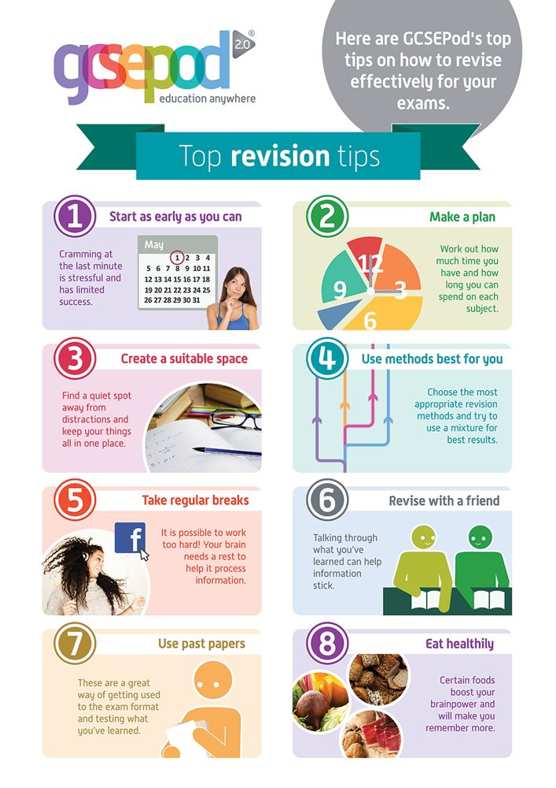](https://www.google.co.uk/url?sa=i&rct=j&q=&esrc=s&source=images&cd=&ved=0ahUKEwj6hOvT9vDRAhVB1hQKHdkpBkcQjRwIBw&url=https://www.pinterest.com/togetherwepass/unisa-revision-tips/&psig=AFQjCNFallgsYkoZgjPlYENqU6UWorwuGQ&ust=1486107953312157)